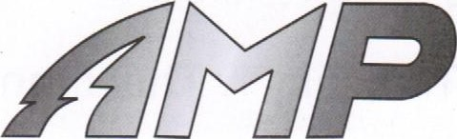
Operating Manual
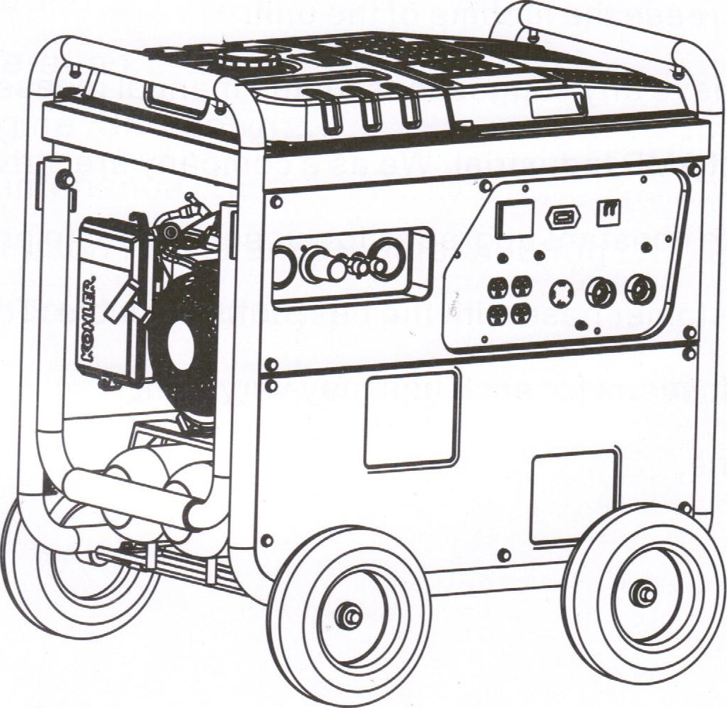
Reading manual before operating.
We want to thank you for your purchase of our state of the art new AMP Triplex 3 in 1 . This manual will tell you how to use and maintain the AMP Triplex 3 in 1 . Please read the manual carefully before operating the machine. Operating the machine in the best conditions will increase the lifetime of the unit.
If you have any suggestions for the manual, please contact AMP. We as a company are striving to make constant upgrades to our equipment to provide our customer base with the best units possible. The specifications for each unit may vary from machine to machine.
Catalogue
Safety... . . . . .
Specifications . . . . . . . . . . . . . . . . . . . . . . . . . . .
Component Identification . . . . . . . . . . . . . . . . . . . . . . . . .5
Preparation... . . . . . . . . . . . . . . . .
Starting... . . . . . . . . . 1 1
Operation... . . . . . . . . . . . . . . . . . . . . . . 1 2
Engine Shutdown.... . . . . . . . . . . . . . . .. . . . . . . . . . . 1 3
Maintenance... . . . . . . . . . . . . . . . . . . . . . . . . . 1 5 Common Faults and troubleshooting22 Schematic Diagram... . . . . . . . .

Warranties... . . . . . . .25

1. Safety Instruction
Please read the manual before operation, failure to comply with the manual could lead to danger of operator, others and the machine.
1 . 1 . Protect yourself and others. Welding can make you and others in danger of many risk factors: Make sure to never weld without a welding mask. This goes for not only the operator, but all other bystanders as well. The damages to eyes include: electric arc, dazzle reflections, dazzle flicker, sparking molten, metal splashing. Looking at welding arc without eye protection can inflict great pain and even temporary blindness. Therefore, this products owner/operator should ensure the welding machine operated by a user with prior welding knowledge. Use this professional protective equipment when operating.
-Face shield
-dedicated heat resistant gloves
-Protective clothing and shoes
1 .2. Do not use machine in area where dust pollution, flammables or explosives are present.
1 .3 Power supply and welding current can cause shock damage. Please do not touch inside or face plate of welding machine at any time. Make sure operator and all other have a dry ground insulation
protection. Do not let your body touch the ground and the electrode at that same time.
1 .4 Welding fumes and gasses can cause serious harm to operator and all other by standards. Please keep your head away from a place you could possibly breathe in fumes and make sure to use the machine in a well-ventilated area. 1 .5 To prevent any fire hazards do not have any residue of gasoline or kerosene on your person, cylinder or piping you may be welding.
1 .6 Do not operate machinery if you have a pacemaker. This includes being anywhere near the machine even if else is operating. The magnetic field produced by the welding machine could have adverse effects on a pacemaker.
1 .7 Welding splatter can cause fire and explosions. Do not weld in dangerous situations such as around flammables, explosives, a closed barrel or pipe.
1 .8 There is extreme heat produced by the exhaust pipe, engine, air compressor and muffler. Please do not touch these parts or have flammables anywhere near the unit. The high temperature produced by the exhaust is capable of igniting any flammables or explosives.
1 .9. It is important that this unit is installed, used and maintained by professionals. Do not tamper or remove any safety or warning signs located on the unit.
1 .10. The engine operates on gasoline. It is important to keep in mind this unit cannot be run indoors. Carbon Monoxide has no odor and can be fatal in a short period of time.
1 .11 . Gasoline is highly flammable and is capable of causing a large explosion. Please shut down the machine before ever adding fuel or oil. When adding fuel or oil make sure it is done in a well-ventilated area. When filling the fuel tank be sure you always leave enough space for natural fuel inflation. Make sure to not smoke near fuel supply. Keep away from all other flames, sparks, etc. Make sure to wipe all leaked fuel on the unit before starting.
1 .12 Take care when attaching your welding leads. Ensure a solid connection at the lead terminals at all times. Inspect your welding leads for damage before each use and never allow them to sit in a damp environment. Avoid dragging your welding leads, as this may cause the insulation to become damaged.
1 .13 Check the oil level prior to each use by removing the oil dipstick. Do not operate the unit if it has become overfilled with oil, as this can affect normal operations. In addition make sure to change the oil on a regular basis.
1 .14 Refrain from using the air compressor when welding. Also, it is recommended that you disconnect all sources from the generator as well when welding.
2. Specifications
 | Welding current range (A) | DC 50 200
 | Duty cycle ( % ) | 50
 | power static characteristic curve | dropping characteristic
Generating | Rated voltage (V) | AC 240/120
 | Rated output (KW) | 5
 | Max output (kW) | 5.5
Air compressing | Starting | Recoil start + pressure trigger
 | Air tank (Gal) | 2X 2.5
 | Alternator output | 1 . 35
 | Pressure( PSI ) | 115
 | Air output (CFM) | 4.4 @ 90pSl
 | Air input( CFM ) | 8
engine | Speed control | Manual operation
 | Cooling system | Air cool
 | Air valve | OHV
 | Ignition system | CID
 | Fuel Tank (Gal) | 7.9
 | Oil alert system | Yes
 | Fuel consumption (g/hp.hr) | 374
 | Start Mode | Recoik electric Remote Start
Complete machine | LengthxWidthxHeight  (mm) | Machine size:
 |  | Outer packing:
 | Weight (Kg) | 153KG
 | IP Grade | IP21
 | Insulation grade
3.Structu re
Note: Do not attempt to modify the control panel in any way. This will void your warranty and could present the potential for equipment failure and personal injury.
7
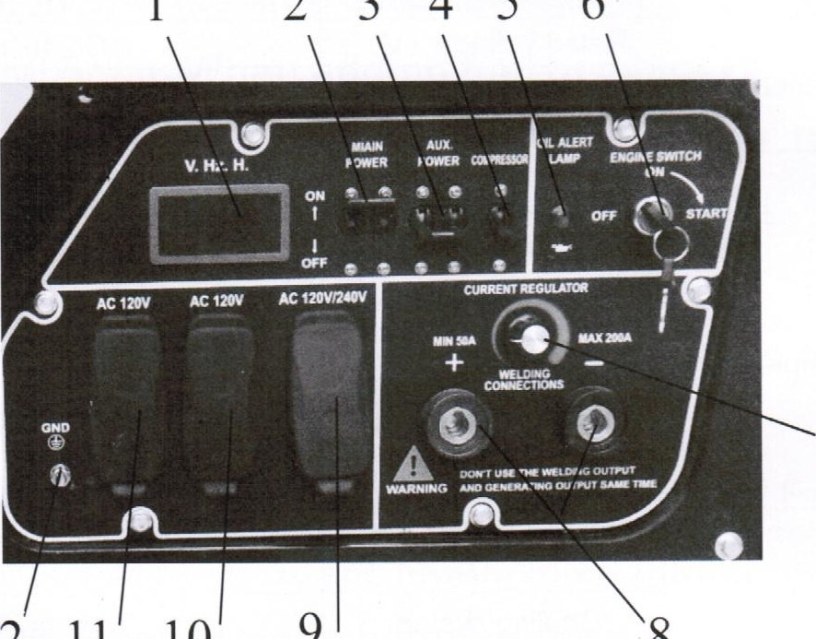
12 11 10
1
23456
9
8

1 . Digital Display
- Main Power Breaker
- Auxiliary Power Breaker
- Air Compressor Breaker
- Oil Alert Lamp
- Engine Ignition Switch
- Welding Current Regulator
- Welding Output Terminals
- 120/240VAC Output
- 120VAC Output
11 . 120VAC Output
12. Ground Terminal

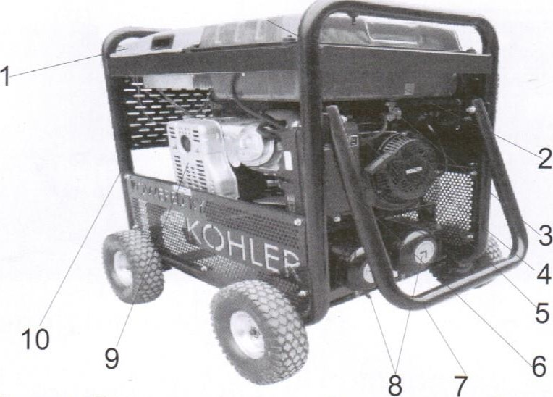
1 . Engine Cover Plate 2. Fuel Tank 3. Fuel Petcock
4. Engine Pull-Start Assembly 5. Engine Choke Lever
6. Air Filter Assembly 7. Handle 8. Water Drain Valve
9. Muffler Assembly 10. Frame
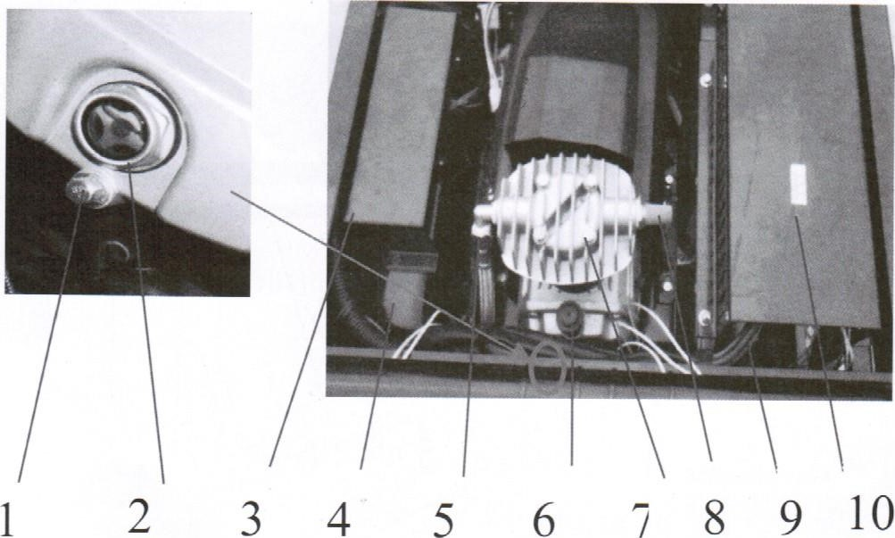
1 . Air Compressor Oil Drain Plug 2. Oil Sight Glass
3. AVR Cover Plate 4. Control Panel Case
5. Exhaust Port 6. Oil Fill Port
7. Air Compressor Cylinder Head 8. Air Filter
9. Air Supply Hose 10. Cover Plate

1 . Engine Oil Drain Plug
3. Air Pressure Relay
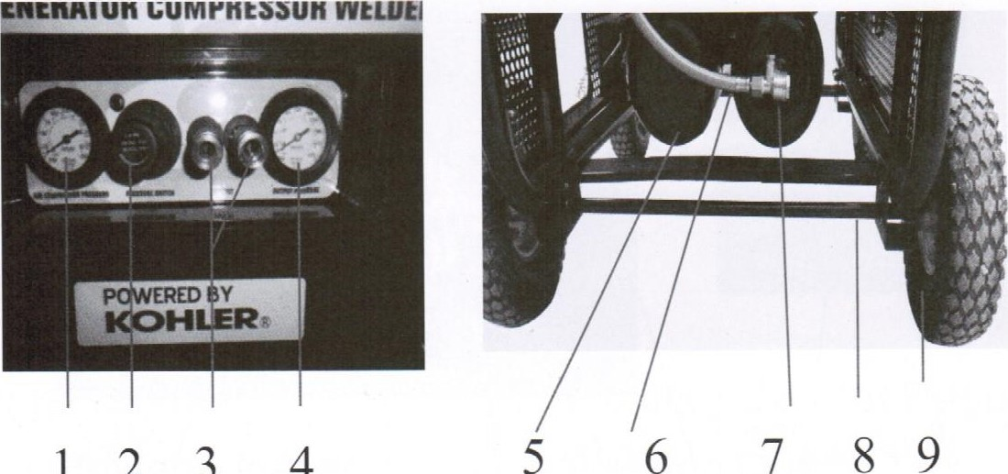
5. Safety Valve
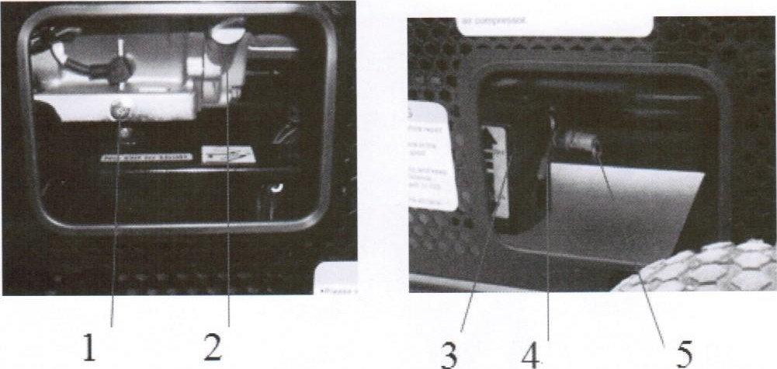
2. Oil Fill Dipstick
4. A/C Switch

1 . Pressure Gauge
3. Air Outlet Connectors
5. Air Tank
7. Air Valve
9. Wheel
2. Air Pressure Regulator
4. Pressure Gauge
6. Air Hose
8. Wheel Axle

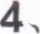Preparation
4.1 Read this manual carefully and understand all operating procedures before using the equipment.
4.2 Make sure the wheel kit is firmly mounted before any type of movement. Please control the speed to avoid jerking.
4.3 The equipment must be stored horizontally in a clean, dry, well ventilated place.
4.4 Please check to ensure all components of machine are securely fastened. If fastener or connectors are loose they must be repaired before running the machine.
4.5 Make sure to always check engine oil before operating machine.
4.5.1 Remove and wipe off dipstick.
4.5.2 Insert dipstick and then remove to check exact level of the oil.
oil to its proper level.
Oil dipstick
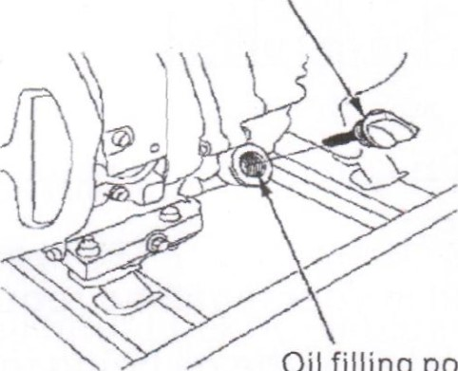
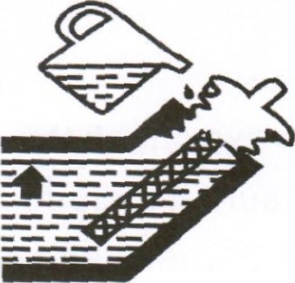
oil upper level
Oil
filling
port
4.6Engine oil recommendation
4.6.1 Oil is a major factor for overall performance of the AMP Triad 3 in 1 . Please use 4 stroke oil that exceeds the standards for API service classification S E .
Always check the API SERVICE label on the oil container to be sure it includes the letters SE.
4.6.2 Check and change the oil in your machine regularly. This will avoid all problems related to the oil being too low, too high, dirty or thick.
4.6.3 SAE I OW-30 oil is recommended. The SAE viscosity grade shows other viscosities to use in different average temperatures.
4.5.3 If the oil level i s below the minimum level add oil to its proper level. We recommend the oil is in the middle of minimum and maximum levels.
30
sw-n-10W-30
-10 O 10 20 30 40L'
Always check the API SERVICE label on the oil container to be sure it includes the letters SE.
4.6.2 Check and change the oil in your machine regularly. This will avoid all problems related to the oil being too low, too high, dirty or thick.
4.6.3 SAE10W-30 oil is recommended. The SAE viscosity grade shows other viscosities to use in different average temperatures.

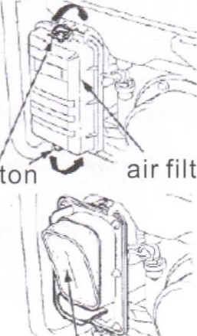
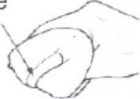
air filter cover foam filtering
Button
core
Air filter element
4.7 Always check the fuel level before operating machinery. Use a strainer when adding fuel and make sure to always leave enough room at the top for fuel inflation to occur. Make sure you securely twist the fuel cap before operating the AMP Triad 3 in 1 . Do not use used, polluted or mixed fuel in the machine.
4.8 Check air filter
4.8.1 Open the clip to loosen the filter cover.
4.8.2 Move the clip and filter cover in order to remove the air filter. Do not damage the cover.
4.8.3 Remove the Filter.
4.8.4 Check the filter. If the filter is dirty, please wash it. If it is damaged, then call AMP for a replacement.
4.8.5 Install filter back into holder.
4.8.6 Install the filter cover and make sure no gap is in-between covers. If there is no filter or filter is damaged it will allow dust into the engine and cause major damages.
5.Starting
5.1 Start the fuel valve
The fuel valve is between fuel tank and the carburetor. When running the unit, the fuel valve is "on" . when stop the unit
,the fuel valve turn to "off". Fuel switch
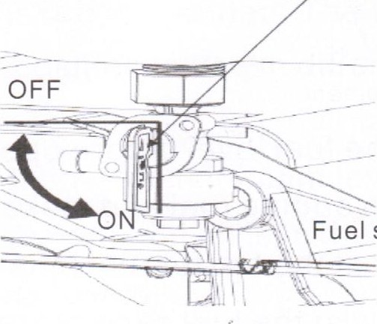Fuel switch
5.2 Try to drain all fuel and turn the fuel petcock to the off position when the unit will sit for a long period of time without use. This will keep the ethanol in gasoline from ruining the carb.
5.2.1 Electric start on the unit: Operate by turning the starting key on the control panel. Turn the key in a clockwise direction to start location until the unit starts. Return the key to "on" location if failed to start, wait 30 seconds and then try to restart the unit.
off: stop the unit start : start the unit on : running the unit
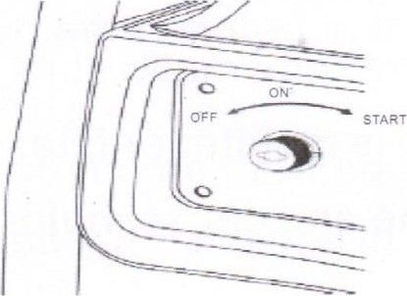
5.2.2 Recoil start: Make sure the unit to the unit is in the "on" position. Pull the re-coil handle slightly until you feel resistance and then pull handle immediately. If failed, repeat until the unit has started. Gentle let the cord back down to avoid damaging the pull cord. Do not let the cord have friction or the cord may wear easily.
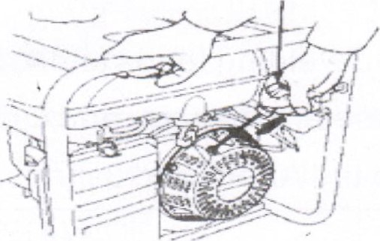
5.2.3 Remote control start
Make sure the key is in the "on" location. Then press the button on the remote control that reads "on". If failed, retry after 30 seconds.
- . OPERATION
  - Ambient temp: welding 14 F- 104 F
  - Transport and storage: -4 F- 131 F
  - Relative humidity: when 104 F < 50%; when 68 F, < 90%. Max altitude equals < 3280.84 feet.
  - Angle of inclination: the unit must be angled less than 10 degrees of the welding supply power.
  - If the unit has been overloaded after connecting the plug, the CB will close itself on the control panel. If this is
true pleased check the other equipment is running properly.
Second check if it is overloaded.

Special Warning
1 . The CB is not in control of the power of the welder.
2. Do not use the welder and air compressor at the same time or generator and welder at the same time for best performance.
6.6 Welding rods and welding leads chart: For your reference below these are the rods and cables we see the best performance in the AMP Triad 3 in 1 .
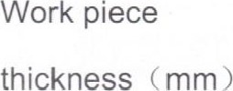
Welding rod  diameter (mm) | 1.6-2.5 |  |  | 2.5-3.2 |  | 3.2-4 | 4.0-5.0 |  | 5.0-6.0
Welding rod  diameter (mm) |  | 2.0 | 2.5 |  | 3.2 |  |  | 4.0 |  | æ5.o
Welding Current  (A) |  | 40-60 | 60-80 |  | 90-130 |  |  | 160-210 |  | 200-270

ENGINE SHUT DOWN
7.1 Remove all connections this includes generator, welding leads and air compressor outputs. Then turn off the circuit breaker. If the air compressor was in use
empty compressor tank of all remaining air. If welding please remove rod connections. Let the unit run for 2-3 minutes, then turn the key on the control panel to the "off" position.
7.2 If the unit must be transported a long distance. Make sure you stop the unit and remove any connections. Try and drain the unit of all remaining fuel in the tank and turn the fuel calve to the off position.
7.3 Make sure to inspect the unit after you have shut it down.
Check the bolts and connections are all secure.

SECTION 8: MAINTENANCE
It is very important to get the best out of your AMP Triad 3 in 1 that you keep up on all maintenance, Regular oil and fluid changes will also ensure you are decreasing the amount of pollution being put into the air. In order to ensure you are maintaining your equipment we have comprised a list of daily checks procedure to be sure your unit is running at maximum potential. If any maintenance procedures need to be conducted by a professional please do so. And for any questions with these procedures feel free to contact a AMP Industrial service technician for step by step directions on how to do so. If the unit is being operated in a dusty area make sure to maintain these checks more frequently.
8.Maintenance
Change oil(when warm the unit, remove the oil to make sure that the drain the oil completely)
Daily maintenance cycle
Item: based on the runing target month or the runing hour to maintain |  | each time | the first month or  20h | every  3month or  50h | every  6month or  IOOh | every I year or 300h
ENG oil | check the level | o
 | change |  |  |  | o
Air cleaner filter | check | o
 | clean |  |  | o
Sedimentation glass | clean
Spark plug | check-adjust
 | replace
Valve clearance | Check -adjust
Combustion chambe | clean |  | every 500h
Case and filter | clean
Fuel hose | check |  | every two years(if necessary,please replace)
8.1 Changing the oil: Make sure you warm up the unit for a short period of time to ensure all oil residues will drain.
8.1 .1 Make sure the unit is off of the ground to leave enough space to drain the oil into a container. Remove the oil plug, oil bolt and the seal.
8.1 .2 Make sure the oil is drained completely. Then tighten the bolt and replace the seal. To purchase a new seal please contact AMP Industrial.
8.1 .3 Fill the unit with oil into the crankcase to the recommended level on the oil dipstick plug. Once you have reached the recommended level tighten the oil plug.
CAUTION: In order to protect the environment, we strongly urge all users to drain the oil into a sealed container. Once finished please dispose of the oil into an oil waste barrel or to a local company that handles waste oil.
8.2 Cleaning the air filter
8.2.1 Use warm soapy water when cleaning the air filter. Make sure you dry the filter before installing.
1 .Soak |  | 2.Squeezing |  | 3.0M |  | 4.Squeezing
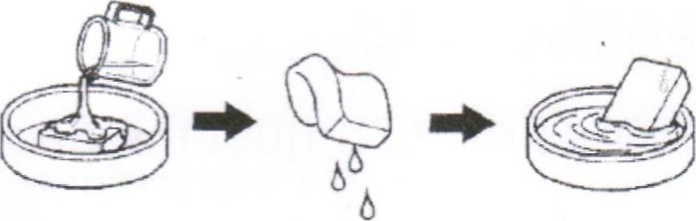
8.3 Spark Plug Maintenance
In order to keep your Triad 3 in 1 running at peak performance, the spark plug must be adjusted to get rid the unit of any carbon laydown. Using the wrong spark plug will damage the engine. Make sure to contacting a AMP service technician before changing the spark plug. Always remember to make sure the unit has had ample time to cool down before you perform any maintenance
on the spark plug.
8.3.1 After letting the unit cool down clean a dirty spark plug by first, removing the cap on the plug. Then you must remove the spark plug with the spark plug remover tool that came in the toolbox of your unit.
8.3.2 Inspect the spark plug after removal. If the electric pole has worn or if there is visible damaged or the plug is broken, please replace the spark plug.
8.3.3 Use the plug gauge to measure the gap between the electric poles. If necessary, you can slightly bend the electric pole to adjust the gap. The gap is 0.7-0.8mm.
8.3.4 Make sure the spark plug is fully sealed. Install the spark plug by hand to avoid any over tightening. After tightening the spark plug, tighten the seal with the spark plug wrench. If the spark plug was used before installing, please re-tighten 1/8-1/4 round. If the spark plug is brand new, please re tighten by ¹/2 round.
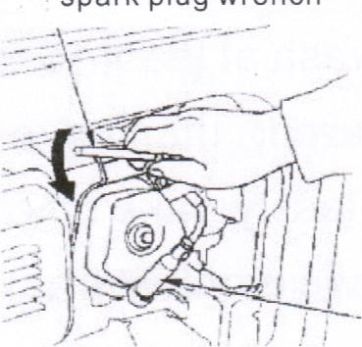
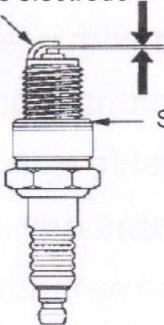
Side electrode spark plug wrench
0.7-0.8mm
Sealing ring spark plug cap
CAUTION: If the spark plug is not fully tightened when reinstalling it could cause the engine to overheat. It is important to avoid any damage that the spark plug is tightened to the correct specifications. If you have any questions, contact a AMP service technician for any information.
8.3.5 Install the spark plug cap.
8. 4 Battery maintenance
When running the machine, charging system will charge battery. But it is for periodically use, battery should be charged every month to make sure its service life and starting effectiveness.
8.4.1 Battery contains high corrosivity and virulent sulfacid (electrolyte).Eye or skin will be third-degree burn once contacted with it.
8.4.2 When working near battery, please put on protective cloth and eye shield. Let children far away from battery.
Attention: come into eye carelessly: use water in the container to wash at least 15 minutes. (water with pressure will let eye injured), then have medical treatment; Contact with skin carelessly: take off cloth and wash skin with much water, then have medical treatment; Come into body carelessly: drink a lot of water or milk, then have medical treatment.
8.5 Fuel
8.5.1 Ethanol in the fuel we purchase can have damaging effects to the fuel system. It is important that you never let fuel sit in the carburetor of the unit for longer than 30 days. If you will not be running the unit for 30 days or longer we strongly urge you turn the fuel petcock off and run the unit until the remaining fuel is burned off.
8.5.2 Metamorphic fuel will cause difficulty starting your 3 in
1 . It will cause colloid sediment to block the fuel system. If you find your fuel to be metamorphic, you should maintain or replace the carburetor immediately.
8.5.3 You must never let fuel sit or be stored for more than
30 days in your AMP Triplex 3 in 1 .
8.6 Taking off fuel tank and carburetor
Fuel is highly combustible and explosive. It is important to remember when handling fuel you can easily be burned or hurt. Make sure the engine is shut down away from heat, sparks and flames. Only deal with fuel issues outdoors.
8.6.1 Put a gasoline container below the carburetor and use a funnel to protect against over spilling.
8.6.2 Loosen carburetor discharge bolt. Discharge any remaining fuel in the carburetor.
8.6.3 After discharging of all fuel into a container re tighten the discharge bolt.
8.6.4 Put the container under the sedimentation glass and use a funnel to protect against over spill. 8.6.5 Dismantle sedimentation glass and turn fuel valve to the "on" position.
Discharge fuel and remove sedimentation glass.
protect spilled
Drainage bolt
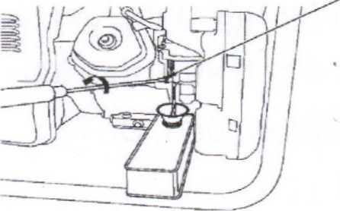
8.6.5 Dismantle sedimentation glass and turn fuel valve to the "on" position. Discharge fuel and remove sedimentation glass.
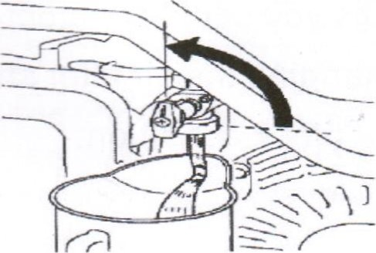
ATTENTION: When using the AMP Triad 3 in 1 and you hear unfamiliar noises coming from the unit it is important to err on the side of caution and contact AMP Industrial immediately.
8.7 Compressor maintenance
8.7.1 For any air compressor oil changes please refer to the engine oil change.
Do not mix or use the same model lubricating oil. 8.7.2 Compressor oil change should reference engine oil change step 8.1 . Use HS-13# compressor oil in the winter. Use HS-19# compressor oil in the summer. Open the drain oil bolt which is located under the main fuel tank. After the oi has fully drained tighten the bolt and then add oil.
8.7.3 Inspect the oil level before use. Do not exceed or add less than the red line level.
8.7.4 Before each use of the air compressor drain the air compressor tanks of air and condensed water build up. The compressor petcocks are located at the bottom of the tanks.
8.7.5 Make sure you clean your air filter every month. If in poor working conditions you should inspect it every two weeks. Cleaning or changing the air filter should be based on oil contamination or block condition.
9 Common fault and processing methods
fault phenomenon | fault cause |  | failure process
Could not  start | - battery low voltage  - fuel cock not open  - Chock valve not open  - Low oil level  - Oil warning system problem  6.Bad fuel oil quality  7.0il circuit block  8.1gnition system problem  9.Carburetor problem | 1 ,  2.  3.  4.  5.  6. 7.  8.  9. | charge battery( only for electric start)  Open fuel cock  Refer step 3  Check oil level, add to the level Pull up warning wire, restart to confirm (after confirm should stop machine)  Change fuel oil  Clean oil circuit  Check and clean spark plug, check ignition coil.  Clean or repair carburetor
genset no output | - voltage meter broken  - Alternator leading wire and control panel wire fall off or not connect well.  - Brush and slip ring do not connect well or disconnection  - AVR control panel broken  - Short circuit, open circuit or grounded wire  - Circuit breaker not open | 1 .  2.  3.'  connect  4.  5.  6. | After confirm, stop machine and replace  Check and repair  Clean slip ring or replace brush or  wire replace  Inspect and repair, or replace alternator winding.  open circuit breaker ( only limited to assistant power)
output voltage high or low | - High or low rotate peed  - AVR issue  - sample wire fall off or loose | 1 .  2.  3. | Adjust rotate speed  Replace AVR  reconnect
output | 1. Rotate speed high or low | 1 . | Adjust rotate speed
current high or low or can not adjust | - AVR issue  - Sample mutual inductor winding  fall off or loose  - Shon circuit, open circuit or grounded winding  - MDS or rectifier diode short circuit or grounded | 2.  3.  4. | Replace AVR  Replace mutual inductor winding  or connect  Check and repair, or replace alternator winding  Replace MDS module or rectifier diode

compressor part overheat temperature | I .  2.  3.  4.  5. | Working pressure high  Not use correct lubricating oil  Ambient high temperature or poor ventilation compressor valve block air leakage or damage compressor can not stop automatically | 1.  2.  3.  4.  5. | reduce working pressure reference this manual and use correct compressor oil  Shift to good ventilation place repair valve block or replace compressor inspect or replace safety valve or pressure relay.
compressor heavy | I . 2. | Discharge pressure high compressor positioning bolt loose | 1.  2. | reduce discharge pressure reposition
vibrate |  | or installation out of level
compressor pressure value can not go up or can not get rated pressure | 1. 2.  3.  4.  5.  6.  7. | Gas circuit not sealed well vent valve air leakage pressure gage broken safety valve air leakage purge valve air leakage compressor stator or rotor short circuit compressor valve block air leakage or damage | 1 .  2. 3.  4.  5.  6.  7. | Inspect or re-seal replace replace replace replace  replace repair valve block or replace compressor
gasholder pressure high or safety valve alerting | 2.  3. | safety valve work pressure high safety valve damage pressure relay broken | 2.  3. | readjust pressure working value replace replace
alternator smoking | I .  2.  3.  4. | Rotor and stator rub overload winding short circuit or grounded  MDS or rectifier diode short circuit or grounded | 1.  2.  3.  4. | Replace or repair  Remove some load  Replace alternator winding  Replace MDS module or rectifier diode
air  compressor do not work | 1  2  3  4  5  6 | alternator no output compressor damage bottom manual control switch is close pressure relay broken special circuit breaker on control panel work  thermal protector at alternator bottom work | 2.  3.  4.  5.  6. | inspect alternator and AVR contact supplier to repair or replace open manual control switch replace pressure relay inspect and recover recover or replace
10. Schematic diagram
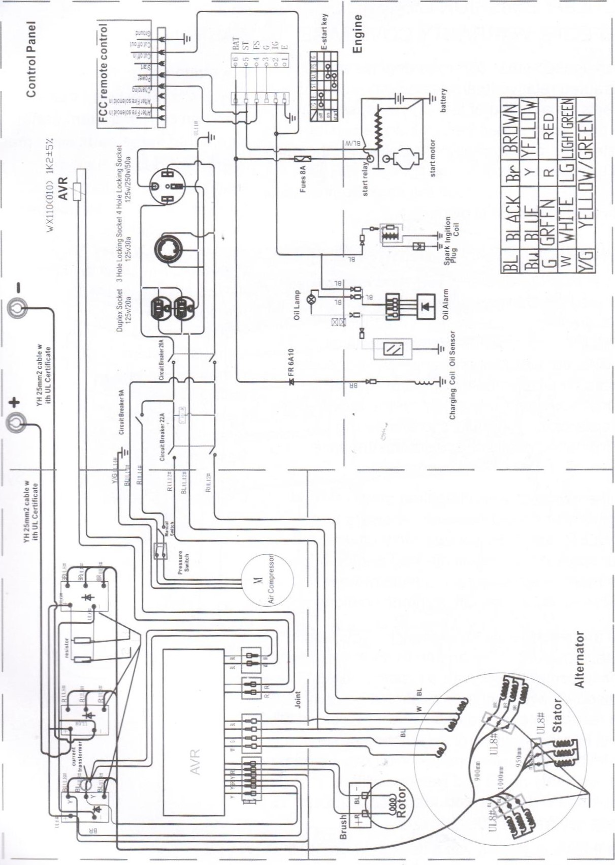

SECTIONI 1 —WARRANTES

KOHLER EMISSION CONTROL DEFECTS WARRANTY COVERAGE
Spark ignited small o ff-road engines are warranted relative to emission control parts defects for a period of two (2) years, subject to the provisions stated below. If any emission related part on your engine is defective, the part will be repaired or replaced by KOHLER. The warranty period begins on the date the product is delivered to the initial owner.

OWNERS WARRANTY RESPONSIBILITY
As the spark ignited small off-road engine owner; you are responsible for the maintenance required, what are listed in the owner's manual. KOHLER recommends that you retain all receipts covering maintenance on your spark ignited small off-road engine, but KOHLER cannot deny warranty solely for the lack of
receipts or for your failure to ensure the performance of all scheduled maintenance.
As the owner of a spark ignited small off-road engine, you should however be aware that KOHLER may deny you warranty coverage if your spark ignited small off-road engine or part has failed due to abuse, neglect, improper maintenance or unapproved modifications.
You are responsible for presenting your spark ignited small off -road engine to an authorized service center as soon as a problem exists. The undisputed warranty repairs should be completed in a reasonable period of time, not to exceed 30 days. For the location of an authorized service

EMISSION CONTROL SYSTEM WARRANTE[PARTS
Coverage under this warranty extends only to the parts listed below (the emission control system parts) to the extent that these parts were present on the engine purchased.
Fuel Metering System
Carburetor and/or internal parts
Intake manifold
Evaporative System
Fuel tank, Fuel cap, and tethe
Air Induction System
Air cleaner*
Intake manifold
Exhaust System
Exhaust manifold
Ignition System
Flywheel magneto
Ignition coil assembly
Spark plug*
Crankcase Emission Control System
Crankcase breather tube

center and any questions you may have regarding your warranty rights and responsibilities, you should call our parts and technical support group toll free at 800-544-2444
The emission warranty is a defects warranty and defects are judged on normal engine performance. The warranty is not related to an in-use emission test.

